**PALMAS NATURE’S PARK RESERVATION SYSTEM WITH INTEGRATED DATA ANALYTICS**

A project study presented to the faculty of

South East Asian Institute of Technology

College of Information and Communication Technology

In partial Fulfillment

of the requirement for the subject

IT 228: System Analysis and Design

**By:**

Ates, Mac Lovell Keith

Justo, Tressia Mae

Canillo, Kenneth

Ombing, Louis Joseph

Milagrosa, John riel

Carballo, Mark Jade

APRIL 2025

**CHAPTER I**

**INTRODUCTION**

**Rationale of the Study**

Technology Systems worth has been proven countless of times now, from technological tools to automation of works, as well as collecting and storing of data, it has been integrated into transportation networks and into society itself, including Resorts and Hotels, integrating technology into their business by using online bookings and platforms, to improve their efficiency and their workflow, a resort reservation system is a means for resorts to implement business through an online platform, namely the availability of paying and reserving rooms and spot on a resort, where in this aspect will be convenient for those customers who wants to reserve a room without going to the venue, which they’ll also be able to keep a record of their transactions, a resort reservation system will ensure a less traffic and much more convenient way to reserve/book your event.

Reservation System is now utilized by a number of businesses from resorts to hotels. reservation system is a system that allows the customer to either reserve a product or book/reserve a place; by doing so it allows them to ensure that the said product/venue is theirs to claim, not only freeing them from the inconvenience of not being able to acquire the product/venue they wish to avail, but to also ensure the efficiency of obtaining the said product.

Resort reservation system is now widely used not only in the local scope but also internationally it is convenient especially in the aspect where the customer would have to know if rooms are fully booked or the cottage are book, as well as check if any of the exclusive pools are book, resort reservation system shows accurate data tracking of the accommodations down to whether the resorts parking lot is full or not, hence the resort reservation system is highly convenient for resorts to have access to.

Face to face booking has its draw backs such as when a high number of customers wants to avail a product/venue it will take time since they’ll have to manually interact with customers and customers must be immediately entertained, whenever something is fully booked, different customer would frequently ask if a venue or room is available which is highly inconvenient.

Hence with our Palmas Water Park Reservation System will cover all those short comings by integrating an online booking where when a customer book through online means the management can easily just approve or reject the reservation since everything is filled out by the customer, which would drastically lighten the management work load since customers won’t have to go to the resorts desk to book a reservation and they can also do it online, and Palmas Water Park Reservation System will also integrate a real time tracking of the cottages which means the customer that is viewing the website would know whether the cottage is booked or not.

(*The Importance of Technology: #5 Is a Must-Know!*, n.d.)

Palmas Nature’s Park started its operation on December 21, 2020, it has pool and cottages there has been 10 employees since it’s been founded, and their management has a face-to-face customer interaction when it comes to making reservations, Palmas Nature’s Park has been operating that way since the day it is founded, when a customer wants to get in the resort they would go through the usual process of choosing the cottages and tallying up the expenses of the said cottages, and when someone wants to book a reservation they would usually be paid in advance and will be recorded on a logbook that the management use.

Palmas Nature’s Park has encountered challenges in their reservations, since

such as:

(1) Customer usually must wait in line waiting for the current customer to finish the transaction just to make a simple reservation making customer leave leading to profit loss, (2) Everything is recorded in a logbook therefore, retrieving of the current reservation is harder than it is since it is not organize and the management doesn’t know if the reservation is correct or not, (3) guest often forget their reservations leading to them not showing up, (4) Payment options cause lag in the transactions which will make management confuse on handling the payments as well as the customer in processing their transactions. (5) Management usually makes mistake in calculating the revenue for the month which makes it so that they don’t know whether they encountered profit loss.

The Palmas Nature’s Park Reservation System with Integrated Data Analytics and Payment Options aims to address these limitations by offering a convenient web system that would allow their customer to access and view their resort and venue and the available reservations, with real-time availability on the cottages, and adhere payment methods as well as data analytical tools that would compute their revenue and losses that will be safely stored in the database and integrates operational reports where customers can repost issues regarding the resort which the employees can easily view through the web portal and address the issues.

**Objectives of the Study**

**General Objectives**

The researchers aim to study and develop a Palmas Nature’s Park Reservation System with Integrated Data Analytics and Payment Options (PNPRS) for Palmas Nature’s Park. located at Barangay New Passi, Tacurong city.

**Specific Objectives**

* To be able to develop a system that allows guest to book cottages, and event spaces, in advance through a web-based portal.
* To create a system that shows real time availability of cottages.
* To make an easily access payment options and the history of the transactions of the customers.
* To develop a notification feature that notify the customers through the web-based portal regarding their reservations.
* To be able to develop a system that allows customer to write operational reports regarding the resort and allows the employees to easily address the reports.

**Scope and Limitations of the Study**

**Scope of the Study**

The Palmas Nature’s Park Reservation System with Integrated Data Analytics and Payment Options is capable of the following:

**Online Reservation System**

This feature allows the customer to make a reservation, whether it is about an reservation posted by the admin or the venue itself through a web-based portal but only in the web app.

**Real-Time Availability**

This allows the customers to check the reservation availability in real-time, making it so that the data provided by the web system is accurate.

**Payment and Billing System**

This feature allows the customers to complete their transactions through the online platform or walk-in of the system making it much more convenient since the customer doesn’t have to go to the venue while making the reservation, but the transaction will only be available through gcash qr code payment.

**Notification & Reminders**

It will automatically send notifications to the customer about their booking confirmations, and status making it so the customer is always reminded and aware, but the notification will only be push-notification on the website.

**Sales Report**

Allows the management to have analytical report to observe the monthly revenue, where the management can view the sales of the resort.

**Limitations of the Study**

The study is only intended for the Palmas Nature’s Park. This research project focuses only on the reservation system and analytical data for customers who want to make a reservation online and for the management that wants to easily view analytical data about the profit, a monthly summary of revenue reports, and real-time venue and cottage tracking. This system will not include functionalities such as sms notifications. The system’s effectiveness depends on the accuracy of data entered by the Palmas Nature’s Park staff. Technical issues or power outages could disrupt system access. The system will be available online on desktop computers and Mobile Phone.

**Significance of the Study**

The system has the potential to significantly impact the school, resort, staff, and customers, leading to an improved reservation process. Specifically, this study aims to benefit the following:

**Owner**

Palmas Nature’s Park System will ensure an efficient sales and management report and will surely aid the resort in producing more income that will help the owner in further developing the resort.

**Palmas Nature’s Park**

Palmas Nature’s Park System will provide the ability for the customer to make a reservation online, without hassle and with convenience.

**Palmas Staff**

The online reservation can alleviate the burden of administrative tasks, reducing stress and improving job satisfaction for the Employees and Management.

**Customers**

The system provides access to real-time availability of the reservations through the system which is convenient for the customers that want to make reservations.

**Researchers**

This is an opportunity for the researchers to utilize their skills and knowledge in research, putting what the researchers have learned as Information Technology students into practice.

**Future Researchers**

This study will be of great help to future researchers who plan to design and develop an improved Reservation System as it will provide them (1) documentation that will serve as the literature, and (2) the source code of the system which will guide in the development of a new, enhanced system.

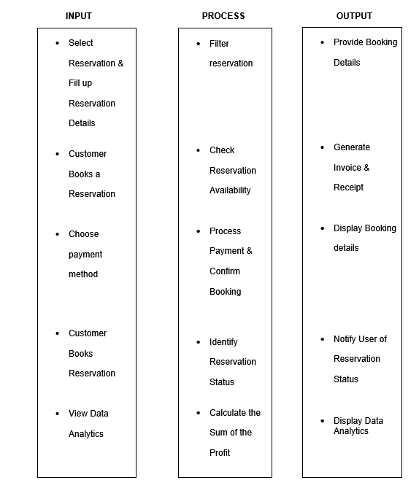**Flow of the Study**



*Figure 1.1: Flow of the Study of* Palmas Nature’s Park Reservation System with Integrated Data Analytics

**Definition of Terms**

**Assessment –** the evaluation or estimation of the nature, quality, or ability of someone or something.

**Automation –** the technique of making an apparatus, a process, or a system operate automatically

**Reservation -** an arrangement to have something (such as a hotel room) held for one's use

**Availability -** the quality of being able to be used or obtained

**Technology -** he application of scientific knowledge for practical purposes, encompassing tools, techniques, and systems to solve problems, accomplish tasks, or achieve specific objectives

**Operational Report** - provides a detailed, often real-time or near real-time, snapshot of a company's day-to-day activities and performance, focusing on areas like production, sales, inventory, and customer service to enable informed decision-making.

**CHAPTER II**

**REVIEW OF RELATED LITERATURE AND STUDIES**

To address many concepts, ideas, and understandings involving both local and foreign literature of the studies, a review of connected literature and studies is established. The information from the past to the present is analyzed and provided in this study, which aids the researcher in creating project proposals. The various studies and publications related to the clinic management system.

**Review of Related Literature**

**Foreign Literature**

**An Online Beach Resort Reservation System: A tool to strengthen TVET to Meet Industry Needs**

(https://www.computersciencejournals.com/ijcai/archives/2023.v4.i1.A.62)

There is a research gap in the research they have conducted, namely is must system is not up to date and can’t demonstrate the efficiency the user and industry expect it to perform specifically common system has, Outdated Reservation Methods, Limited Accessibility, Manual Management, hence the research decided to conduct a research on how to improve the current resort reservation system the research stated as followed: Beach resort and reservation is one among the recreational platforms that provides a space for summer hangout or vacation where people visit to express relaxation and reliefs, every aspect of recreation and resort centres has also join the internet platform in the promotion of their businesses and creation of awareness to increase their business earns and the number their online customers is growing by the day. The Paper aimed at designing a platform (website) using Atican beach resort as a define study for user to be able to participate and book for reservation and also provide a distance platform for online over the distance user to be able to enjoy the facility of beach resort during summer vacation. The system GUI (Graphical User Interface) was implemented using Hypertext Mark-up Language (HTML), PHP and MySQL were used for the database. A non-empirical method was adopted and majority of the survey was made online acquiring documents from internet archives related to word match solutions. The beach resort online reservation system would help the resort to be more productive and competitive (James & Osasere, 2023).

**Hotel Booking Cancellation Prediction Using Applied Bayesian Models**

(https://arxiv.org/abs/2410.16406)

The study tackled the problem of predicting hotel booking cancellations, which critically affect revenue and operations. Previous methods like machine learning had limitations in handling uncertainties and lacked flexibility for real-time updates. This research applied Bayesian Logistic Regression and Beta-Binomial models to a dataset of 36,285 bookings, focusing on 12 key features. Results showed Bayesian Logistic Regression performed better, identifying special requests, parking availability, and room type as the strongest predictors of cancellations. The findings provide hotels with a practical tool to manage overbooking and pricing, though future research should test the model across different hotels and include more variables for broader applicability.(Jishan et al., 2024)

**Accommodation Reservation and Booking Portal for Tourism**

(https://www.researchgate.net/publication/371829968_Accommodation_Reservation_and_Booking_Portal_for_Tourism)

This study developed an Online Reservation and Booking Portal to address inefficiencies in traditional hotel booking systems, which often rely on manual processes and lack user-friendly interfaces. The portal, built using HTML, CSS, PHP, MySQL, and XAMPP, enables customers to book hotel rooms, spa services, and cabs online while providing administrators with tools to manage bookings and hotel details. Key features include a secure login system, dynamic search functionality, and digital billing. Testing confirmed the system's reliability, with successful validation of modules like user authentication, payment processing, and data management. Future enhancements could include mobile app development, AI-driven personalization, and integration with third-party services to further improve accessibility and user experience. The project demonstrates the potential of technology to streamline hospitality operations and enhance customer satisfaction.(Hasan Ayon, n.d.)

**Local Literature**

**Sipaway Resort Reservation System**

(https://www.scribd.com/document/716867328/Sipaway-Reservation-1​)

The researcher concluded that since the expansion of the hospitality industry progresses, the need for the improvement and development of the system also rises that states that, The Sipaway Resort Reservation System assists its establishment in revolutionizing their way of a user-friendly and seamless booking for the guest’s leisure getaways and providing a convenient and secure platform to select and reserve accommodations that are offered. Increasing their guests and efficiency. This innovation is a solution tailored for a flexible hospitality industry that aims to enhance how resorts manage their bookings and enhance customer interactions that will optimize the business’s coherence. Today’s Era Hotel Reservations are making their way to the online space. Forums, Online Discussions, and Online Support these are some of the new features that they can achieve. Thus, the employees and staff can focus on the online support system and have less paperwork to handle because all the files will be on the computer. The capabilities of this system are endless some hotels can cater to online ordering, Taxi, etc. Finally, Online Hotel Reservation is a must in this era without this your business will probably fail because of a lack of recognition.

The main purpose of the Sipaway Reservation System is to change how customers create and tailor their accommodations according to their budget and give them access to a seamless reservation. Additionally, our goal is to create a booking system that is easy to use so that guests can view real-time availability and pricing, empowering visitors to make wise choices. More details of the project consist of using three programming languages to develop the system: HTML, PHP, CSS, and MySQL. These will be the core necessities of completing the project. The Implementation of this system will give a boost to the hotel management in the ongoing competition of the industry. Providing an additional range of benefits that will fulfill the resorts’ needs in a managerial aspect of the business.

The main objective of this study is to make an Online Reservation System targeted to a Sipaway Resort that uses a traditional recording method. This aims to make the hotel management transactions effortless and once implemented will offer a trustworthy, capable, and legitimate web application. This system will be beneficial also to the staff and the administrators of the hotel (John et al., 2024).

**Revitalizing Hospitality Services: The Transformation of Mary Alston Hotel’s Reservation System of Trinity University of Asia**

(https://stepacademic.net/ijcsr/article/download/446/218/)

The study addressed a specific gap in research by focusing on the relationship between mobile game usage and the academic performance of Grade 11 General Academic Strand (GAS) students at Calamba City Senior High School. While previous studies explored general effects of gaming, few had investigated this specific demographic and context. To examine this, the researchers employed a quantitative approach using a descriptive-correlational design. Data were gathered through a self-made survey questionnaire, validated by experts, and administered to 100 purposively selected Grade 11 GAS students. Results showed that 59% of the respondents played mobile games for three to six hours daily, with the majority engaging in multiplayer online battle arena (MOBA) and shooter games. The respondents' average general weighted average (GWA) was 88.9, categorized as “Very Satisfactory.” Statistical analysis using Pearson correlation revealed an r-value of -0.324 and a p-value of 0.001, indicating a significant negative relationship between the number of hours spent on mobile games and academic performance. The study concluded that higher mobile game usage was associated with lower academic performance, underscoring the potential negative impact of excessive gaming on students’ educational outcomes.(Caritos et al., 2024)

**Booking and Reservation System: A Unified Application Using Location-Based Services for Sustainable Tourism Networks**

(https://www.researchgate.net/publication/381506499_Booking_and_Reservation_System_A_Unified_Application_Using_Location-Based_Services_for_Sustainable_Tourism_Networks)

The study addressed the lack of research on how second-year English major students at Thai Nguyen University of Education developed and applied learning strategies when using the eJOY Go application. Previous studies had not sufficiently focused on the specific strategies learners used with digital tools like eJOY Go in Vietnamese contexts. The researchers employed a descriptive quantitative method, utilizing a structured questionnaire to gather data on the types of learning strategies used by students. The findings revealed that students most frequently used cognitive and metacognitive strategies, particularly repetition and summarizing, with mean scores indicating a high level of usage, such as a mean of 3.95 for repetition. In contrast, social strategies were used less often. The analysis identified statistically significant patterns in students’ preferences for certain strategies. The study concluded that learners actively engaged with various strategies while using eJOY Go, with cognitive and metacognitive strategies being the most prevalent. These outcomes supported the application's effectiveness in promoting independent language learning and highlighted the value of incorporating mobile-assisted language tools into English language education.(Reginald Ryan U. Gosela & Riah E. Encarnacion, 2024)

**Review of Related Studies**

**Foreign Studies**

**Design and Development of an Online Room Reservation System for Silverline Guest Lodge.**

(https://www.researchgate.net/publication/378867456_Design_and_Development_of_an_Online_Room_Reservation_System_for_Silverline_Guest_Lodge​)

The researcher has identified the problems of the old reservation system the research states that: Collectively, the hotel industry is the most under automated segment of the international hospitality industry, with processing, management and distribution of data being handled manually. The use of a manual system is not only tedious and complicated, but also leads to inefficiency in business operations, unfavorable cash flow and a low revenue portfolio. This study presents the design and development of an Online Room Reservation System for Silverline Guest Lodge, that is aimed at replacing the manual system currently in use. A survey was conducted at Silverline Guest Lodge in Lusaka in order to gather system requirements. After design and modeling, the developed system was trialed on site and online reservations were captured successfully. The Online Room Reservation System presented in this study was developed using the iterative software development model. The software tools used in this study included Notepad++ Text Editor, PHP, MySQL, and Application Programming Interfaces (API’s) for Stripe and PHP Mailer. The hardware tools used included a Hewlett-Packard (HP) Laptop computer running Microsoft Windows 10 Enterprise, with a Pentium (R) Dual-Core Processor. This study showed that the adoption of technology plays a critical role in the hotel industry with regard to improved operational efficiency, maintenance of a competitive advantage, increased revenue portfolio and enhanced customer satisfaction (Nsama, n.d.).

**Optimizing Airline Reservation Systems with Edge-Enabled Microservices: A Framework for Real-Time Data Processing and Enhanced User Responsiveness**

**(**https://arxiv.org/abs/2411.12650​)

The research identifies several gaps in existing airline reservation systems, including the limited adoption of edge computing, fragmented microservices architectures, challenges in real-time data synchronization, insufficient focus on passenger-centric performance metrics, and limited case studies and experimental data. 1 To address these gaps, the study proposes a framework utilizing an edge computing and microservices architecture. 2 Key components of the system include microservices deployed and managed using Kubernetes, a real-time message processing system with Kafka, and monitoring and management tools like Prometheus and Grafana. 3 While the paper focuses on the design and theoretical framework, it anticipates improvements in scalability, latency, and user responsiveness. 4 The proposed architecture was tested through simulations, demonstrating a 60% reduction in average latency and a 20% increase in throughput, with a 25% improvement in user satisfaction.(Barua & Kaiser, 2024)

**Local Studies**

**A Web based Resort Management System for the Quite Place Resort**

(https://www.scribd.com/document/606193259/A-Web-based-Resort-Management-System-for-the-Quite-Place-Resort)

The limitation of the research stated that, guests make a personal trip to the resort they desire to stay at in order to make reservations for rooms. This approach takes too much time and work from the visitor. The existing approach might also have issues with walk-in visitors who can't reserve rooms because they don't know in advance if the hotel can still accommodate them, so the researchers of the study stated, To improve the resorts' customer services, the researchers proposed a web-based resort management system for the selected resort of their study. The idea seeks to offer resort visitors a platform where they may quickly, accurately, and easily reserve their itinerary and lodging in advance. The manual method, which is prone to several difficulties, will be replaced by the proposed technology. The guest will utilize the system to plan and reserve their stays at the resort in advance. The system will also be used by the resort management to handle guest reservations. The resort can increase revenue and enhance the overall experience of its visitors by using the system. The responders, target users, and a panel of IT experts will all be given the opportunity to provide feedback after the proposed system has been constructed. In order to ensure smooth functionality and operation, the application will go through the verification and testing process. IT professionals will also assess the application to make any necessary improvements. Quite Place Resort is a resort located at KM. 14, Barangay Tabunan, San Juan St. Dakbanwa sang Bago, 6101 Negros Occidental. The resort uses a Conventionally, resort visitors contact the hotel directly to ask questions and make reservations. Both the resort visitors and the receptionist must expend considerable time and effort using the aforementioned technique. Additionally, customers are unable to compare the amenities offered by similar resorts. As a manual management process, the resort management must keep track of customer information and bookings on paper, which is extremely difficult for the Management Group. Additionally, Management must verbally explain to the customer all other information, such as availability, amenities, and prices. The resort industry will gain a lot from the deployment of the proposed system. The hotel can welcome more visitors each day and handle their requests and reservations with ease. Additionally, resort visitors can easily make reservations without expending a lot of time or effort. Additionally, the researcher also used the model, Waterfall method, the linear sequential mode (Daryll Torreson Nov 09, 2022).

**Viajeros: The Assessment of an Online Minibus Ticket Reservation System**

(https://journal.formosapublisher.org/index.php/ijis/article/view/5430/5836)

The research identified several gaps in the current systems related to reservation and rental services. These gaps include lack of centralized platforms, limited user accessibility, and inefficient manual processes that hinder customer satisfaction and operational efficiency. To address these issues, the study employed a system development methodology that followed the Agile model, allowing iterative development and continuous feedback integration throughout the project lifecycle. The programming language used for the development was PHP, paired with HTML, CSS, and JavaScript for the front end, while MySQL was utilized as the database management system to store and manage data efficiently. The respondents of the study consisted of a mix of system users, including administrators and clients, who were directly involved in evaluating the system’s performance and usability. For testing purposes, the System Usability Scale (SUS) was administered, yielding favorable results that indicated the system was generally easy to use and met user expectations. The evaluation and conclusions drawn from the SUS scores and other feedback confirmed the system’s effectiveness in delivering its intended features. Upon implementation and deployment, the system demonstrated reliability in real-world scenarios, improving service processes and enhancing user experience by providing a more streamlined and accessible platform for reservations and rentals.(Jerome P. Cabatit Jr et al., 2023)

**Web-Based Venue and Reservation Management System with Data Visualization**

(https://www.dlsu.edu.ph/wp-content/uploads/pdf/conferences/research-congress-proceedings/2022/EBM-10.pdf)

The research identifies a gap in the absence of an efficient system for monitoring and evaluating the performance of Grade 12 STEM students in work immersion, particularly addressing the need for automated documentation and real-time monitoring. The system development methodology used is the Agile model, which allowed iterative development and continuous feedback throughout the project phases. The programming language utilized for system development is PHP, while MySQL served as the database management system. The respondents involved in the evaluation included a combination of teachers, students, and IT experts, ensuring diverse feedback from different user roles. Usability testing was conducted using the System Usability Scale (SUS), which yielded an average score of 87.25, indicating excellent usability. The evaluation further concluded that features such as automated logbook management, performance tracking, and activity monitoring were highly effective in achieving their intended purposes. The system was successfully implemented and deployed within the senior high school setting, providing stakeholders with a functional and user-friendly platform for managing work immersion requirements.(Lapuz et al., n.d.)

**CHAPTER III**

**RESEARCH METHODOLOGY AND DESIGN**

This chapter presents theories associated with obtaining necessary to be used in this study, software methodology, research design, and system development phases which include the planning, design, development, testing, deployment, and review.

**Environment**

The study took place at the Palmas Nature PARK, National Highway, Barangay New Passi, Tacurong city

**Software Methodology**

The Agile methodology will guide the development of the Palmas Nature's Park Reservation System This approach emphasizes iterative progress through four phases: planning (requirement gathering), development (sprint-based coding), testing (user feedback), and deployment (launch with continuous improvements). Agile was chosen for its flexibility in adapting to the park's evolving reservation needs while delivering functional components quickly.



*Figure 3.1: Software Model: Agile Model for PALMAS NATURE’S PARK RESERVATION SYSTEM WITH INTEGRATED DATA ANALYTICS that illustrates the System Development Process.*

**System Development Phases**

**Determining Requirements**

The requirements for PALMAS NATURE’S PARK RESERVATION SYSTEM WITH INTEGRATED DATA ANALYTICS were determined by interviewing the target users. First, they were asked how the processes in Palmas Nature Park are done. Second, they were asked about what part of their processes they find to require improvements/streamlining. The researchers summarized their findings; Booking, Lack Resort Information and Sales Report. The customer needs to go on the resort in order to make a reservation, and the management stated that making an online reservation system will be much more convenient for the customer and will also boost their income. The customer has no way of knowing if the resort is already fully booked or not making it so that when they arrive at the resort and it is fully booked it’ll be inconvenient for them. The staff manually tally up the revenue the staff can do it but there may be some slight miscalculations at times, and the staff also added that it’ll be much more efficient if there is a system that can tally up for them.

**User Design**

**Prototype**

The prototype of the Palmas Nature's Park Reservation System (PNPRS) was developed based on the researchers' findings to address the key challenges identified in the current manual reservation process. First, the online booking system was designed with user convenience in mind, allowing guests to easily reserve cottages and event spaces through a web-based portal. The system displays real-time availability to prevent double bookings and ensure accurate information. Second, the payment process was streamlined through GCash QR code integration, providing a secure and efficient transaction method while automatically recording payment history for both customers and management. Third, the notification system was implemented to automatically send booking confirmations and reminders via website push notifications, reducing no-shows and improving communication. Fourth, the administrative dashboard was designed to generate analytical reports, including monthly revenue summaries and operational reports, giving management clear insights into business performance. Finally, the inventory tracking feature monitors all park facilities in real-time, from cottages to parking spaces, ensuring efficient resource management. The prototype focuses on automating previously manual processes while maintaining an intuitive interface for both guests and staff, directly addressing the pain points of long wait times, disorganized records, and revenue tracking difficulties identified in the study.

**Test**

The testing phase of the Palmas Nature's Park Reservation System (PNPRS) prototype was conducted in collaboration with the park's management staff and select frequent customers. The researchers demonstrated the system's functionality to these key stakeholders, showcasing features such as the online booking process, real-time availability updates, GCash payment integration, and administrative reporting tools. During these sessions, target users were encouraged to perform test reservations and explore the system's interface to evaluate its usability.

**Refine**

The refinement of the system was based on the initial prototype and the suggestions gathered from target users during testing. First, the reservation module was enhanced to automatically update inventory levels, deducting booked cottages and facilities from available stock in real-time. Second, the customer records were improved with additional filtering options, allowing staff to sort entries by booking date and customer type. Third, the reporting feature was upgraded to generate downloadable files for monthly revenue reports and operational summaries. These refinements were implemented to address specific user needs while maintaining the system's core functionality.

**Construction**

The construction of the system started after the prototype was finalized and approved. The development process was divided into several key sections to ensure organized implementation. First, the reservation section was built, incorporating all the design elements from the user testing phase while maintaining its critical connection to the inventory system. This section handles all booking transactions and real-time availability updates. Second, the customer management section was developed, which was divided into two parts: the basic customer information records and the complete booking history log. The basic records store essential guest details, while the history log maintains comprehensive data of all past reservations and transactions. Third, the reporting section was constructed, designed to pull data directly from the reservation and customer management sections. This section generates various reports including financial summaries and facility usage statistics. Finally, the inventory control section was implemented, with direct links to both the reservation and reporting sections. This integration ensures automatic updates to facility availability and maintains accurate stock levels across all system modules. Throughout construction, all sections were developed to work with a shared database, allowing seamless data exchange and system-wide consistency.

**Implementation**

In the implementation phase, the system is to be handed over to the target user. The system will streamline the processes in Palmas Nature Park

**Business Model Canvas**

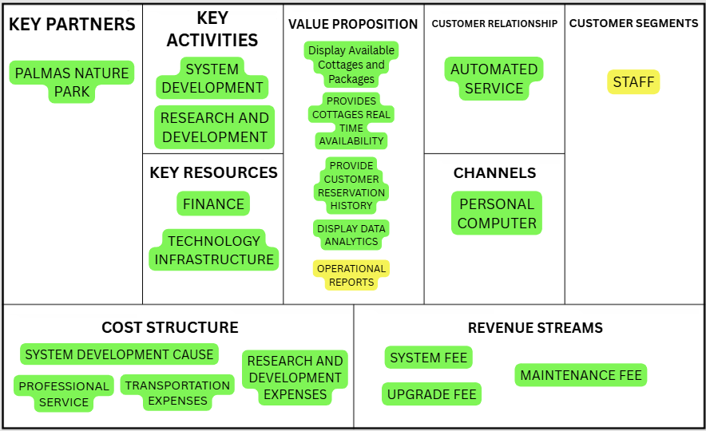

*Figure 3.2 Palmas Nature Park Reservation System Business Model Canvas*

*This is the strategic management and lean startup template for the development of the Palmas Nature Park Reservation Systemvwith Integrated Data Analytics. This is the overview that lays out both what is the system for and how it will run.*

**Gantt Chart**

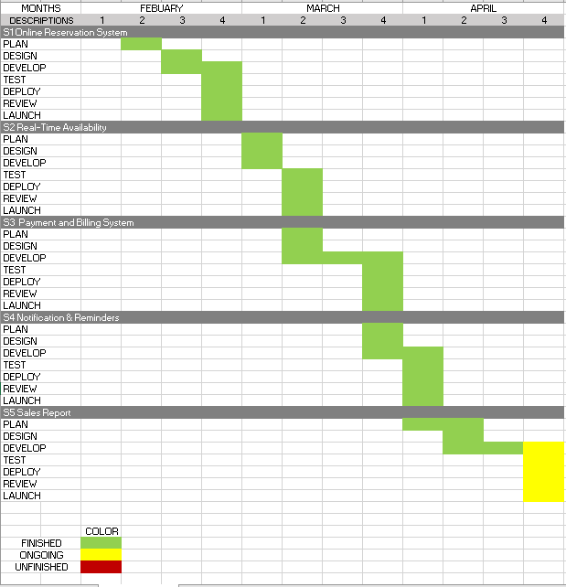

*Figure 3.3: Gantt Chart*

*This chart illustrates this project’s schedule. This illustrates the start and ending week of the terminal elements and summary elements of the project. Terminal elements and summary elements comprise the work breakdown structure of the development of the system.*

**Functional Decomposition Diagram**

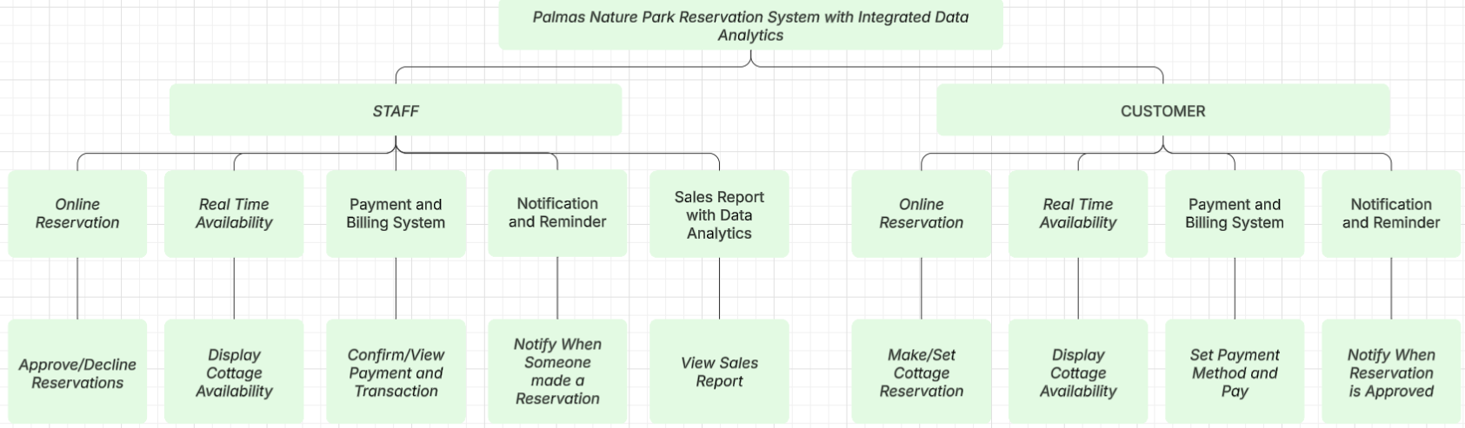

*Figure 3.4: Functional Decomposition Diagram*

*This figure shows the flow of the SEAIT SCMS: School Clinic Management System.*

**Use Case Design Phase**

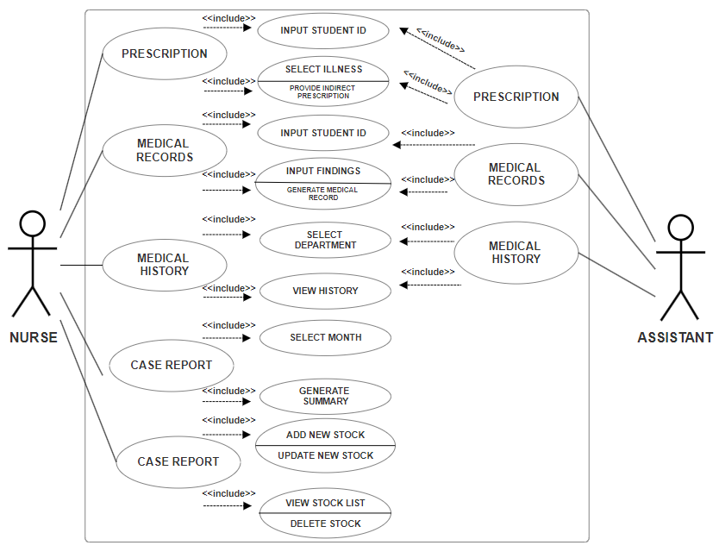

*Figure 3.5: SEAIT SCMS Use Case Design*

*A use case diagram is a graphical depiction of a user's possible interactions with a system.*

**Use Case Matrix**

| **General Characteristics** | |
| --- | --- |
| **Intent** | To identify the purpose of the features that Palmas Nature Park Reservation System with Integrated Data Analytics has |
| **Scope** | The scope of this Use Case is Staff(Admin) and Customer(User) Only |
| **Level** | 2nd Level |
| **Author** | Mac Lovell Keith Ates, Tressia Mae Justo, Kenneth Canillo, Louis Joseph Ombing, John Riel Milagrosa, Mark Jade Carballo |
| **Last Update** | May 16, 2024 |
| **Status** | Ongoing |
| **Primary Actor** | Staff(Admin), who has access to all system functions |
| **Secondary Actor** | Customer(User). Can only make and view reservations |
| **Precondition** | The developer must assist the admin and user for using this system |
| **<Dynamic Precondition>** | The admin and user must explore the system to familiarize with the functions that run without encountering problems |
| **Assumptions** | All the Dynamic Preconditions are running successfully |
| **Trigger** | When the user login and makes a reservation, the admin will then be able to approve or decline the reservation |
| **Success Post Condition** | After login, all the functions and features that are based on the current problem was running successfully with little precondition |
| **Failed Post Condition** | Other modules are still on progress |
| **<Model>** | Use Case Matrix |
| **Operation Concepts** | In implementing this system, the system must run according to the feature that the developers created in observing the current problems of the respondents. The functions will help in managing the Palmas Nature Park in day-to-day operations and monthly sales reports with data analytics. |
| **Overview** | Several Modules are not fully functional and are still in progress. Analyzing and correcting the errors will ensure smooth use before full implementation. |

*Table 3.1: PNPRS Use Case Matrix.*

**Storyboard**

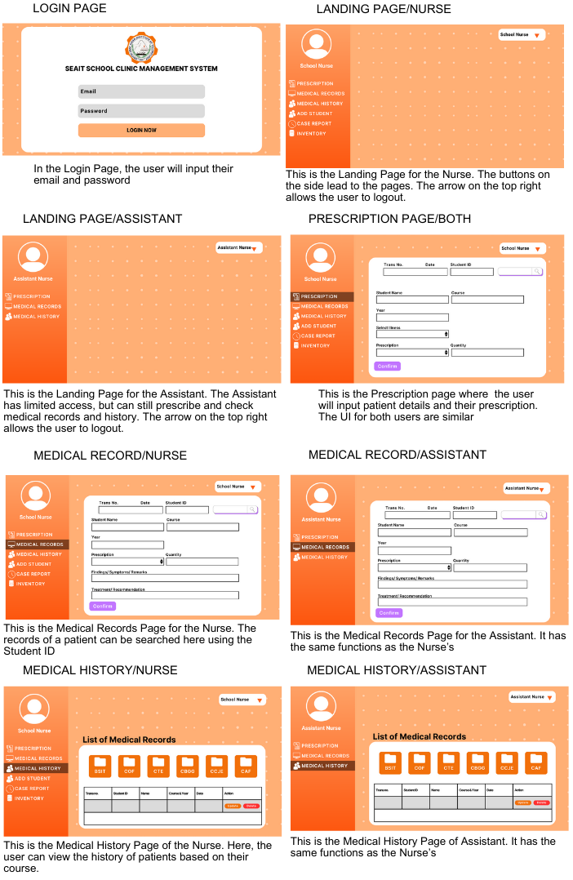

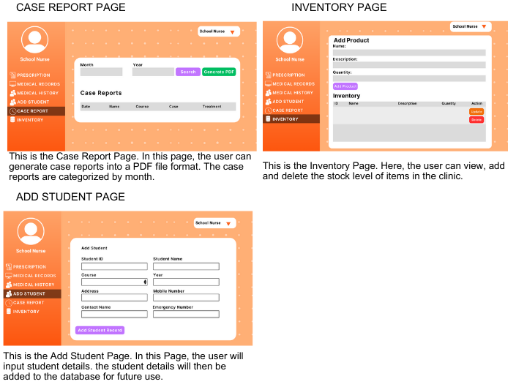

*Figure 3.6: SEAIT SCMS storyboarding into the system.*

**Forms**

**Login Pag**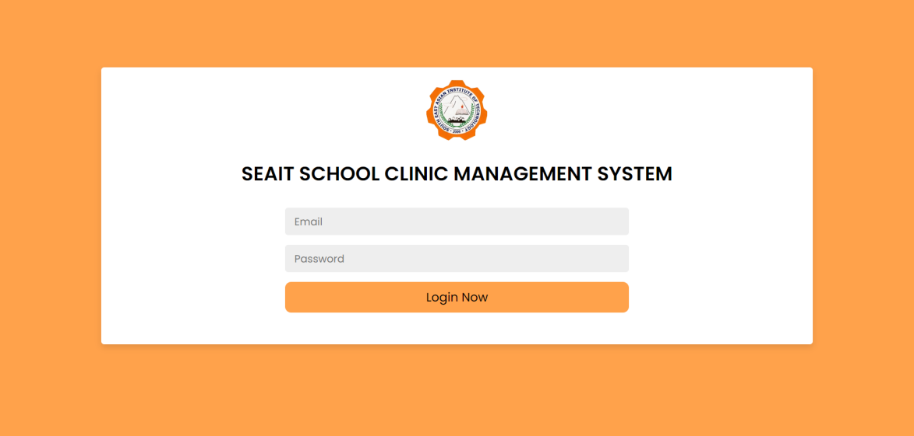

*Figure 3.7.1: This is the Login Page where the user inputs their login details.*

**Prescription Page**

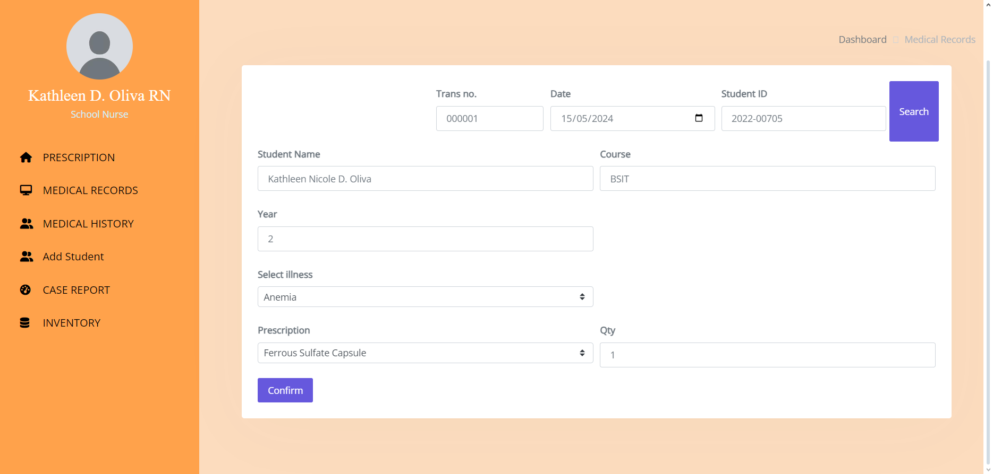

*Figure 3.7.2: This is the Prescription Page where the user inputs the patient details.*

**Add Student Page**

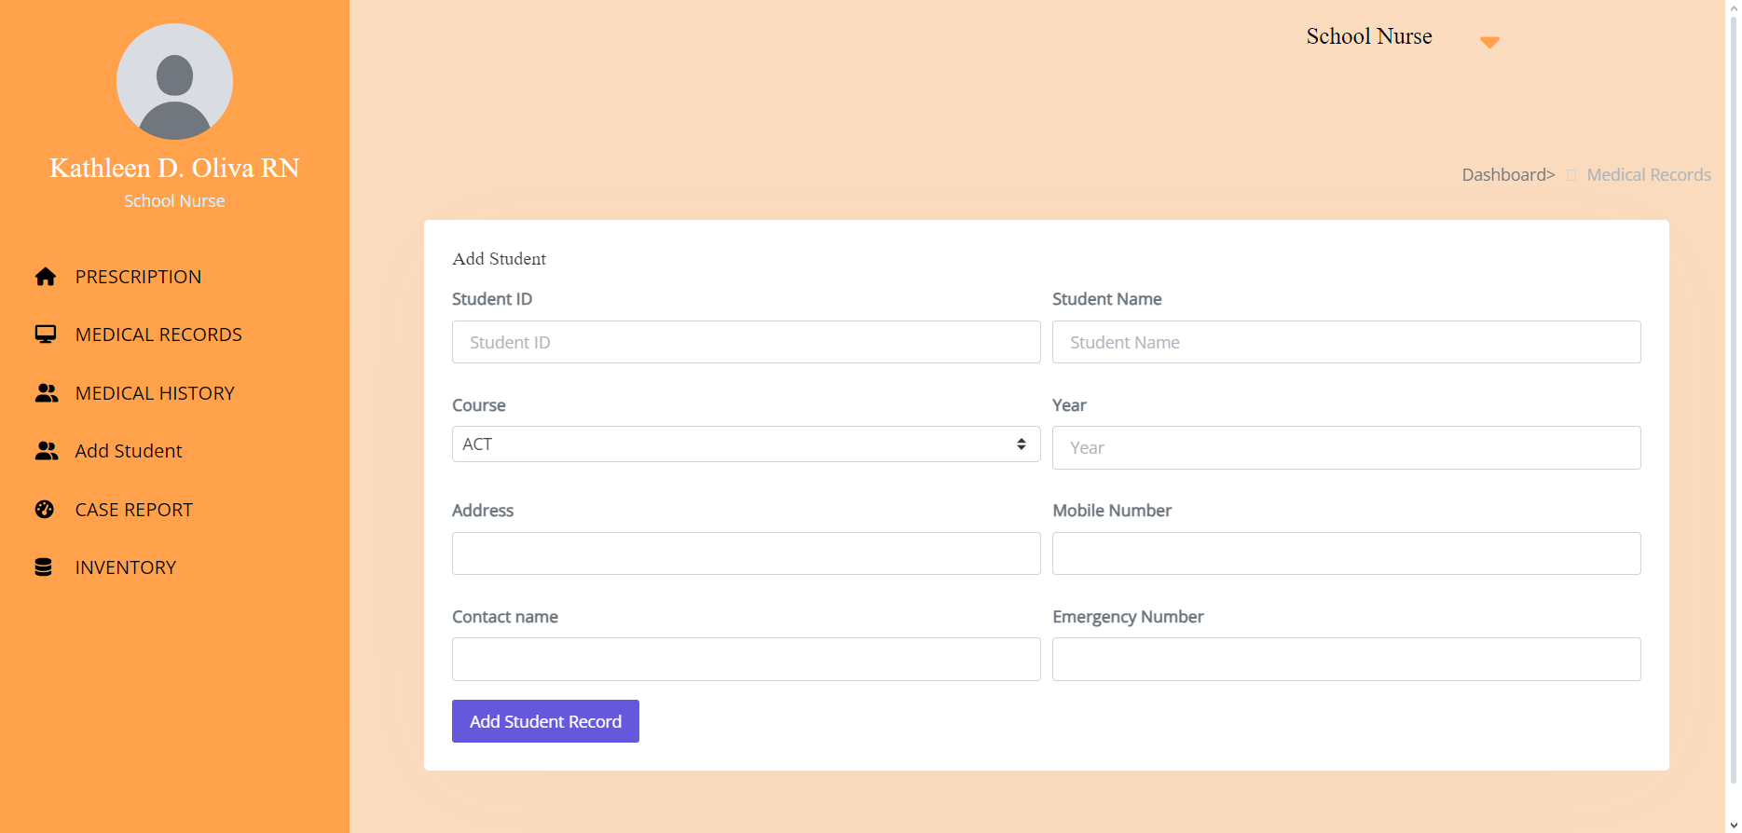

*Figure 3.7.3: This is the Add Student Page where the user adds a student to the database.*

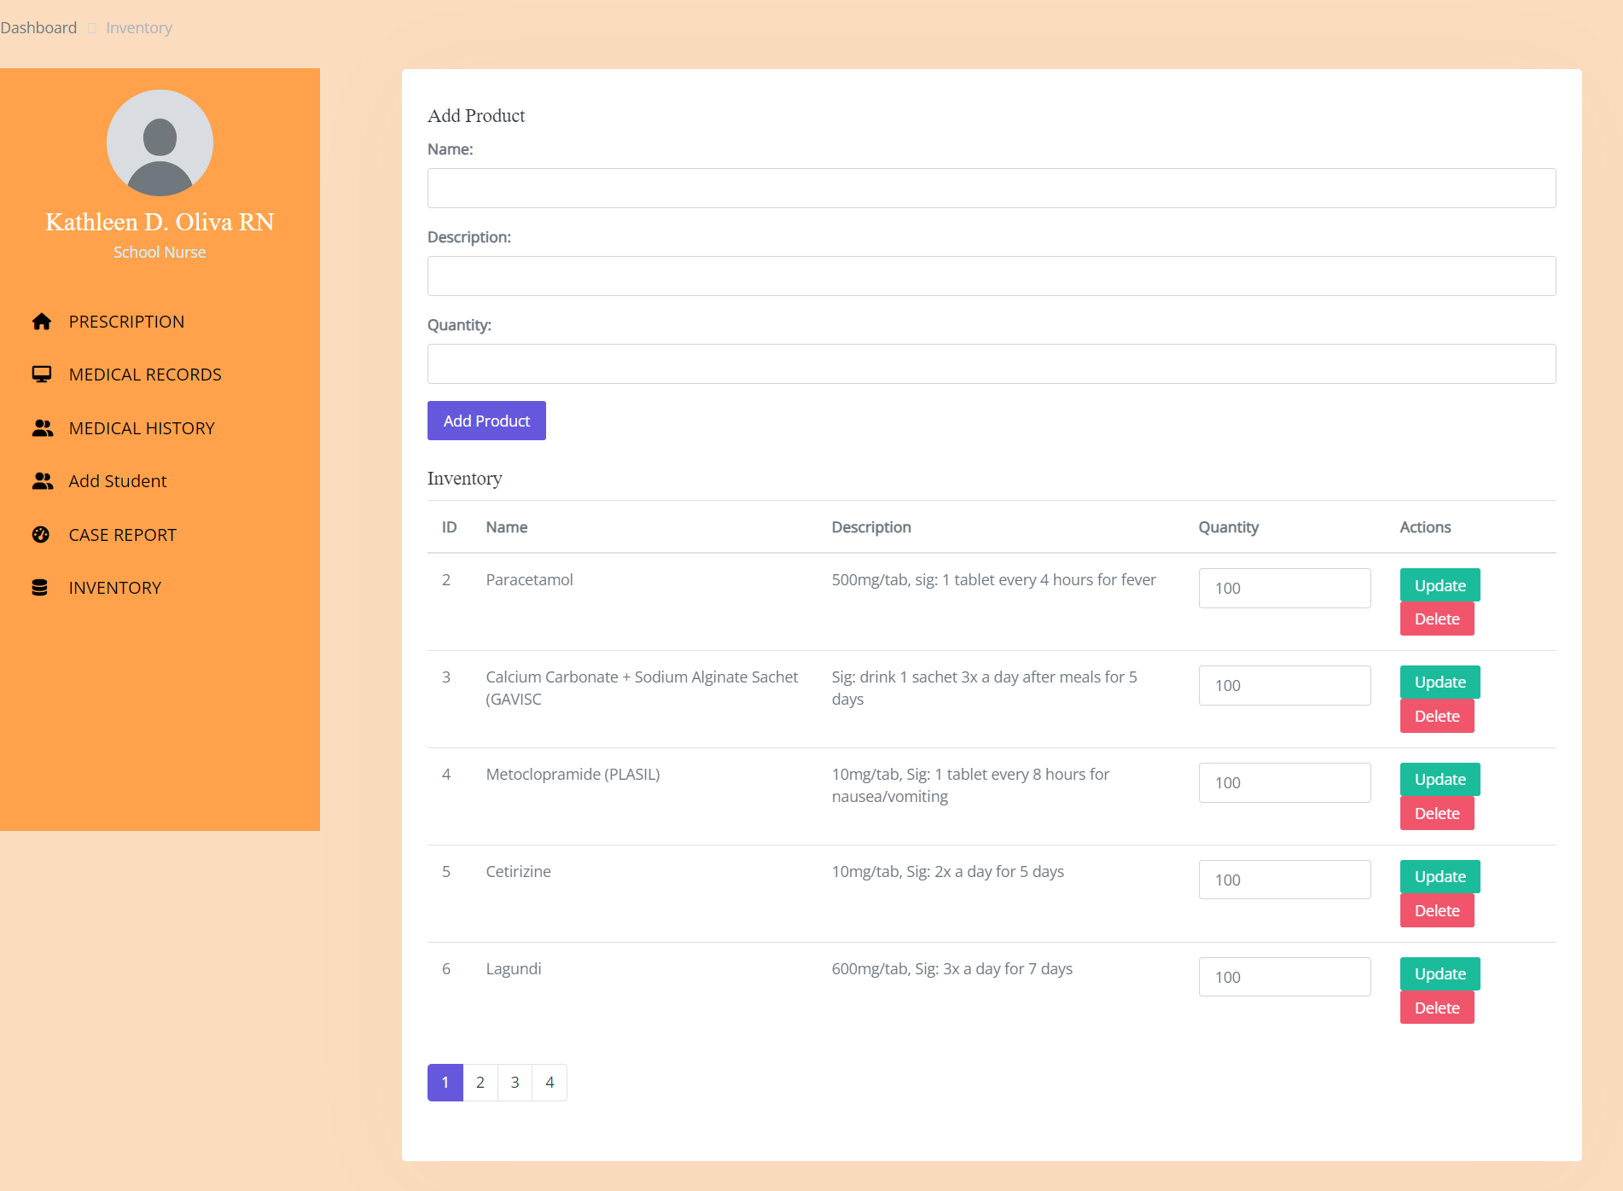**Inventory Page**

*Figure 3.7.4: This is the Inventory Page where the user views, adds, and deletes stock of items.*

**Reports**

**Case Report Page**

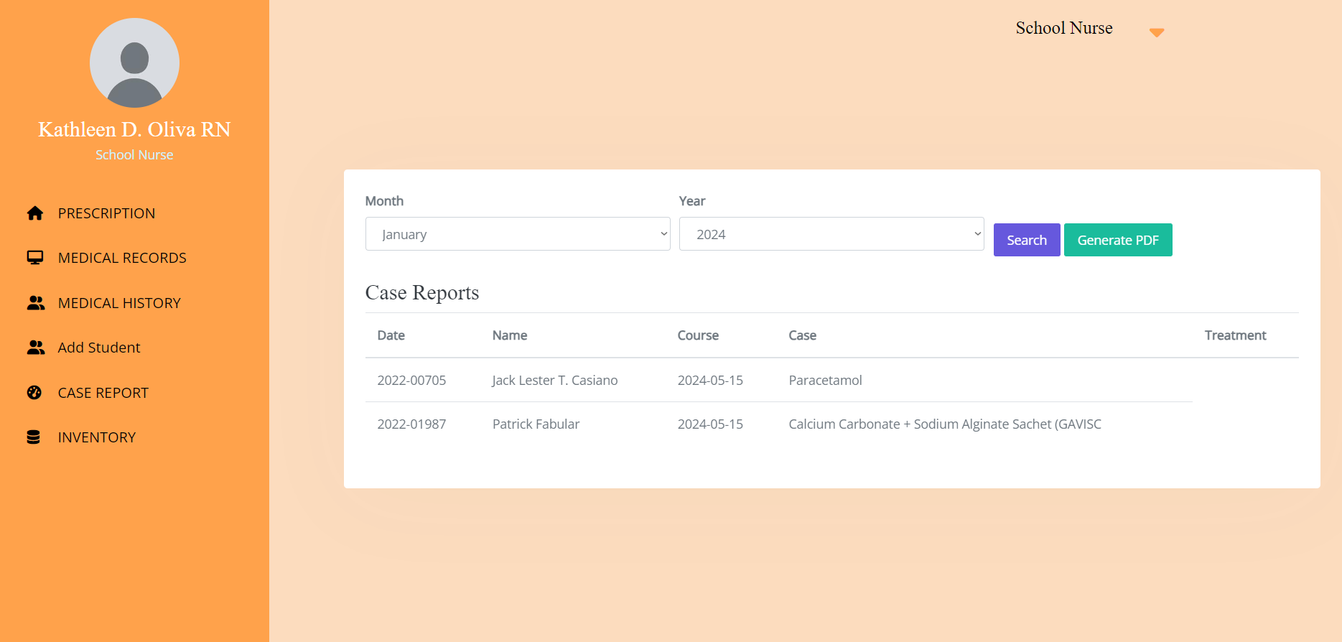

*Figure 3.8.1: This is the Case Reports Page where the user can view the cases by month and generate a report into a PDF file.*

**Case Report PDF File**

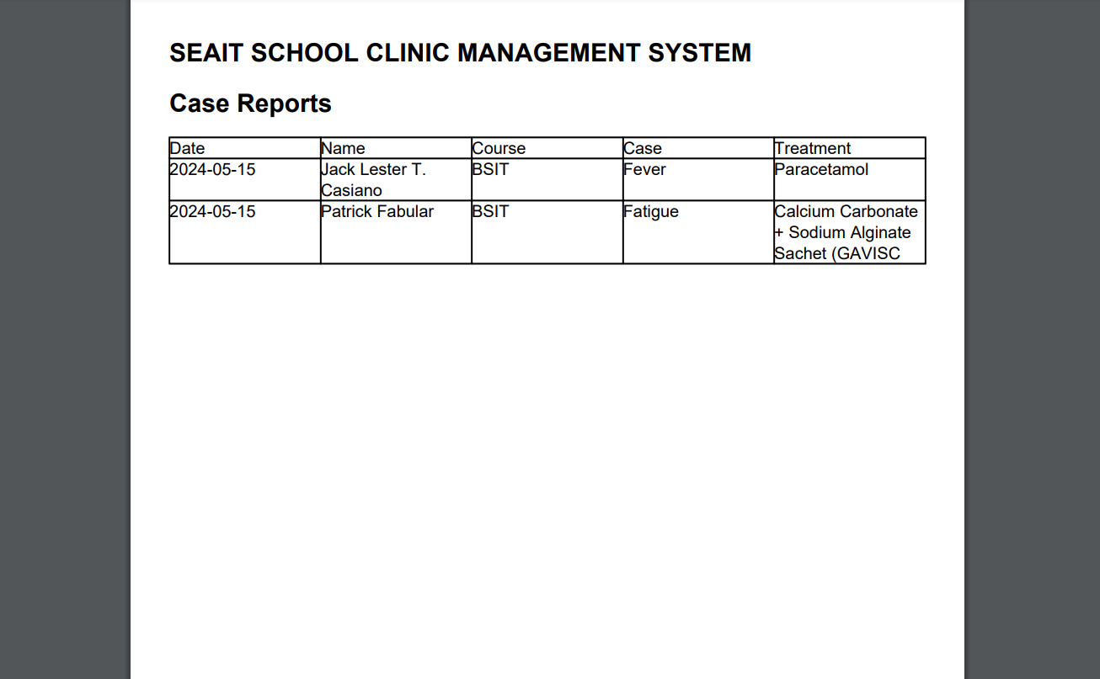

*Figure 3.8.2: This is the Case Report PDF file generated for the Month of May.*

**Database Design**

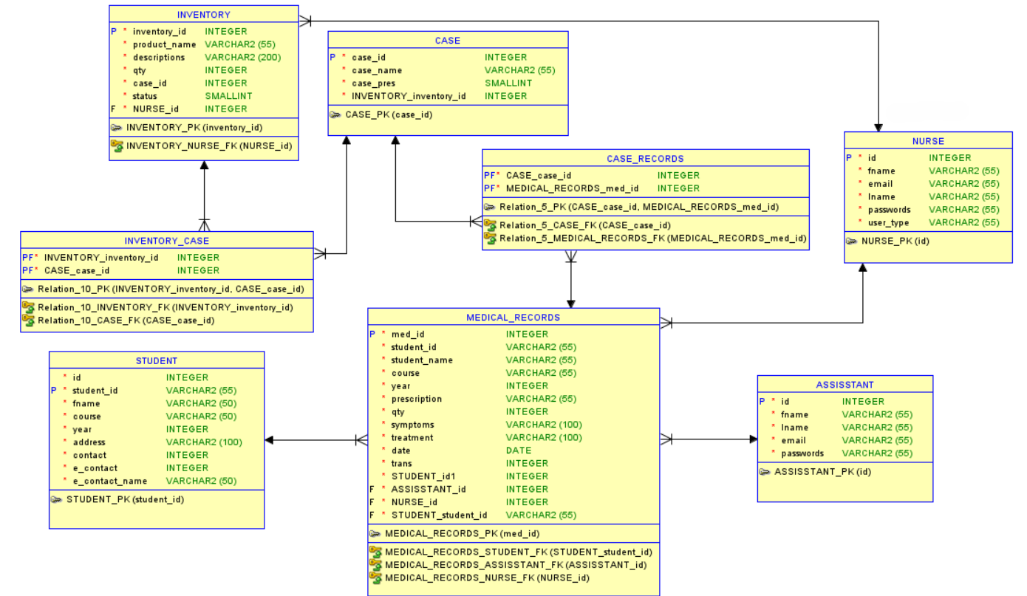

*Figure 3.9: SEAIT SCMS Database design.*

*This figure will determine what data is stored and managed.*

**Entity Relationship Diagram**

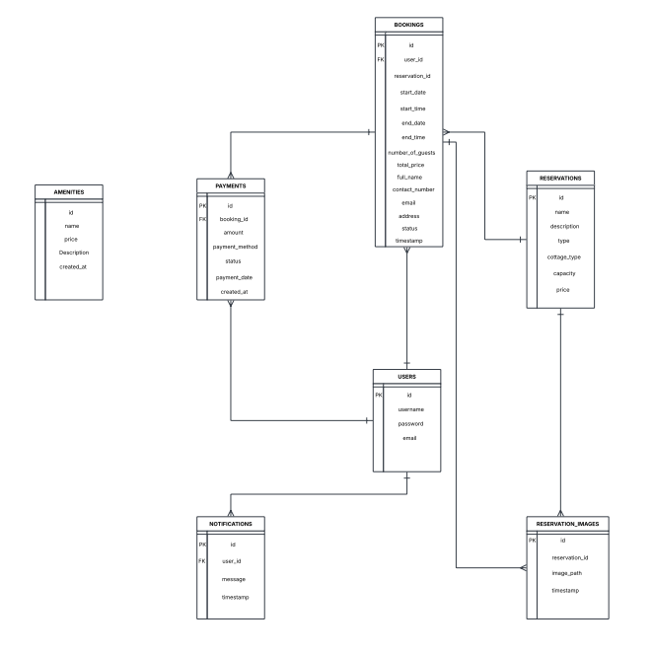

*Figure 3.10: Entity Relationship Diagram to depict relationships among the users, objects, or events within the PALMAS NATURE PARK*

**Data Dictionary**

|  |  |  |  |  |
| --- | --- | --- | --- | --- |
| **Table Name** | | **nurse** | | |
| **Description this table is blahblah** | | | | |
| **Attribute** | **Data Type** | **Null** | **Default Value** | **Description** |
| Id | int(11) | No | PK | The ID of the Nurse |
| Fname | varchar(55) | No |  | Nurse’s first name |
| Email | varchar(55) | No |  | Nurse’s email |
| Lname | varchar(55) | No |  | Nurse’s last name |
| Passwords | varchar(55) | No |  | Nurse’s password |
| User_type | varchar(55) | No |  | Type of the user being login to the system |

*Table 3.2.1: Data Dictionary Nurse Table of SEAIT SCMS.*

|  |  |  |  |  |
| --- | --- | --- | --- | --- |
| **Table Name** | | **Assistant** | | |
| **Attribute** | **Type** | **Null** | **Default** | **Description** |
| Id | int(11) | No | PK | The ID of the Assistant |
| Fname | varchar(55) | No |  | Assistants’ first name |
| Lname | varchar(55) | No |  | Assistants’ email |
| Email | varchar(55) | No |  | Assistants’ last name |
| Passwords | varchar(55) | No |  | Assistants’ password |

*Table 3.2.2: Data Dictionary Assistant Table of SEAIT SCMS.*

|  |  |  |  |  |
| --- | --- | --- | --- | --- |
| **Table Name** | | **Medical_Records** | | |
| **Attribute** | **Type** | **Null** | **Default** | **Description** |
| Med_id | int(11) | No | PK | Medical Record ID |
| Student_id | varchar(55) | No | FK | Student id |
| Prescription | varchar(55) | No |  | Patient prescribed medicine |
| Qty | int(11) | No |  | Quantity of prescribed medicine |
| Symptoms | varchar(100) | No |  | Symptoms shown by the patient |
| Treatment | varchar(200) | No |  | Treatment given to the Patient |
| Date | date | No |  | Date of transaction |
| Trans | int(11) | No |  | Transaction number |
| Assistant_id | int(11) | No | FK | Id of the assistant |
| Nurse_id | int(11) | No | FK | Id of the nurse |

*Table 3.2.3: Data Dictionary Medical Records Table of SEAIT SCMS.*

|  |  |  |  |  |
| --- | --- | --- | --- | --- |
| **Table Name** | | **Student** | | |
| **Attribute** | **Type** | **Null** | **Default** | **Description** |
| Student_id | varchar(55) | No | PK | Student id |
| Fname | varchar(50) | No |  | Student’s name |
| Course | varchar(50) | No |  | Student’s course |
| Year | int(11) | No |  | Student’s year |
| Address | varchar(100) | No |  | Student’s address |
| Contact | int(11) | No |  | Student’s contact number |
| E_contact | int(11) | No |  | Emergency contact number of the student |
| E_contact_name | varchar(50) | No |  | Name of the emergency contact |

*Table 3.2.4: Data Dictionary Student Table of SEAIT SCMS.*

|  |  |  |  |  |
| --- | --- | --- | --- | --- |
| **Table Name** | | **Case** | | |
| **Attribute** | **Type** | **Null** | **Default** | **Description** |
| Case_id | int(11) | No | PK | Id of the case |
| Case_name | varchar(55) | No |  | Name of the case |
| Case_pres | varchar(50) | No |  | Prescribed medicine for the case |

*Table 3.2.5: Data Dictionary Case Table of SEAIT SCMS.*

|  |  |  |  |  |
| --- | --- | --- | --- | --- |
| **Table Name** | | **Inventory** | | |
| **Attribute** | **Type** | **Null** | **Default** | **Description** |
| Inventory_id | int(11) | No | PK | Id of the product |
| Product_name | varchar(55) | No |  | Name of the product |
| Descriptions | varchar(55) | No |  | Description of the product |
| Qty | int(11) | No |  | Amount of the product |
| Case_id | int(11) | No | FK | Identifies which case the product is associated to |
| Status | smallint | No |  | Is used to tell if there is a certain amount left |
| Nurse_id | int(11) | No | FK | Id of the nurse |

*Table 3.2.6: Data Dictionary Inventory Table of SEAIT SCMS.*

**Network Design**

Network design is the integration of the connection type of the devices to achieve end-to-end communication between the devices in the network, which helps to identify the type of topology the SEAIT School Clinic Management System is going to use.

*Figure 3.11: SEAIT School Clinic Management System Network Design*

**Network Topology**

The Network model that will be used is the Stand Alone topology model. In this model, the network is independent of any other node in the network and is often for an offline system. The system is designed to be offline and house its functions and data in the storage of the computer of the user.

*Figure 3.12: SEAIT School Clinic Management System Network Topology*

**Development/Construction/Build Phase**

**Technological Stack**

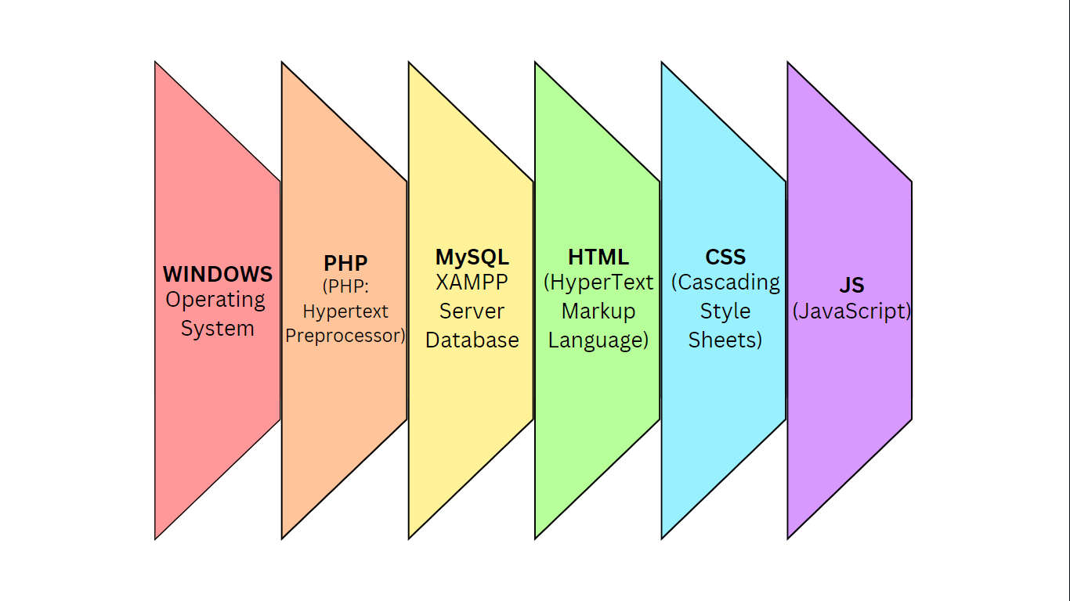

*Figure 3.13: SEAIT School Clinic Management System Technology Stack*

**Software Specification**

Language: PHP

Technology: HTML, CSS Framework, JS, PHP

Database: MySQL XAMPP Server

IDE: Visual Studio Code

Operating System: Microsoft Windows 10

**Hardware Specification**

Processor: Intel Core i3 6th gen

Hard Disk: 464 GB

RAM: 8.00 GB

**Program Specification**

Language: PHP

Database: MySQL

IDE: Visual Studio Code

**List of Modules**

**Automated Prescription Generator Module**

This module automatically prescribes over-the-counter (OTC) medications for a predefined list of common illnesses.

**Electronic Medical Record Module**

This module stores electronic medical record (EMR) for each patient consultation.

**Medical History Access Module**

This module shows medical history of each patient, containing their check-up records at the clinic.

**Case Report Automation Module**

This automatically generates case reports monthly in a PDF file.

**Medical Inventory Management Module**

This module monitors stock levels of all medications and notifies the clinic staff when stock levels are low, under a predefined threshold. It automatically reduces stock when a prescription is done.

**Bibliography**

Barua, B., & Kaiser, M. S. (2024). *Optimizing Airline Reservation Systems with Edge-Enabled Microservices: A Framework for Real-Time Data Processing and Enhanced User Responsiveness*. https://arxiv.org/abs/2411.12650v1

Caritos, J. A., Ignacio, M. A., Maglipon, M. K., Patron, E. J., Utanes, Ei. D., Llevado, Ma. F., Donor, E., & Bunag, F. (2024). Revitalizing Hospitality Services: The Transformation of Mary Alston Hotel’s Reservation System ofTrinity University of Asia. *International Journal of Computing Sciences Research*, *8*, 2677–2694. https://doi.org/10.25147/ijcsr.2017.001.1.180

Hasan Ayon, M. (n.d.). *Accommodation Reservation and Booking Portal for Tourism*. https://doi.org/10.13140/RG.2.2.35282.32966

James, A. O., & Osasere, A. L. (2023). An online beach resort reservation system: A tool to strengthen TVET to meet industry needs. *International Journal of Computing and Artificial Intelligence*, *4*(1), 36–44. https://doi.org/10.33545/27076571.2023.v4.i1a.62

Jerome P. Cabatit Jr, Mariya Donica Leinne B. Capia, Jan Lorenz P. Tubije, Sean Kent P. Hermoso, & Cris Norman P. Olipas. (2023). Viajeros: The Assessment of an Online Minibus Ticket Reservation System. *International Journal of Integrative Sciences*, *2*(8), 1207–1222. https://doi.org/10.55927/ijis.v2i8.5430

Jishan, M. A., Singh, V., Ghosh, A. K., Alam, M. S., Mahmud, K. R., & Paul, B. (2024). *Hotel Booking Cancellation Prediction Using Applied Bayesian Models*. https://arxiv.org/abs/2410.16406v2

John, C., Michael, S. E., Ho, J. T., Kail, F., Paol, D. E., & Ssdcc Olaguer, P. (2024). *Sipaway Resort Reservation System In Partial Fulfillment of the Requirements for the Course of the College of Computer Studies Researchers: Reignier Wil S. Labay*.

Lapuz, I. A., Riguera, R., Sienna Sesbreno, A., Torres, R. M., & Franco, G. R. (n.d.). *Web-Based Venue and Reservation Management System with Data Visualization*.

Nsama, L. (n.d.). *Design and Development of an Online Room Reservation System for Silverline Guest Lodge The International Journal of Multi-Disciplinary Research Design and Development of an Online Room Reservation System for Silverline Guest Lodge*. www.ijmdr.net

Reginald Ryan U. Gosela, & Riah E. Encarnacion. (2024). Booking and Reservation System: A Unified Application Using Location-Based Services for Sustainable Tourism Networks. *International Journal of Advanced Research in Science, Communication and Technology*, 739–749. https://doi.org/10.48175/ijarsct-18889

*The Importance of Technology: #5 is a Must-Know!* (n.d.). Retrieved March 11, 2025, from https://www.simplilearn.com/importance-of-technology-article